A TECHNICAL REPORT ON THE MACHINE LEARNING MODELS FOR AREETA

BY ONANEFEOGHENE KWODE

TABLE OF CONTENTS

Overview of the Report………………………………………………………………………1
Tools and Libraries……………………………………………………………………………3
Data Preprocessing……………………………………………………………………………6
Lstm and recurring neural networks…………………………………………………………8
Testing, validation and prediction generation………………………………………………11
Snapshot of Code……………………………………………………………………………12

OVERVIEW OF THE REPORT

The report explains the step by step processes and tools involved in developing the Sales and Expense Prediction Model.
The Architecture and design of the model (LSTM) will be explained, that is… the math behind the prediction generation, then the data processing stages for the data used to train the model, the training of the model, and the testing.
The Libraries and Framework used will be highlighted, and the Notebook used for coding.

- The Technical Report assumes the same implementation steps for both models
- The Technical Report explains the Sales Prediction and Expense Prediction models

TOOLS AND LIBRARIES

The main tool used for the implementation is Anaconda tool, Jupyter notebook for Python programming, this IDE uses cells each containing a code of it’s own, instead of a single space for all code like the regular IDEs.

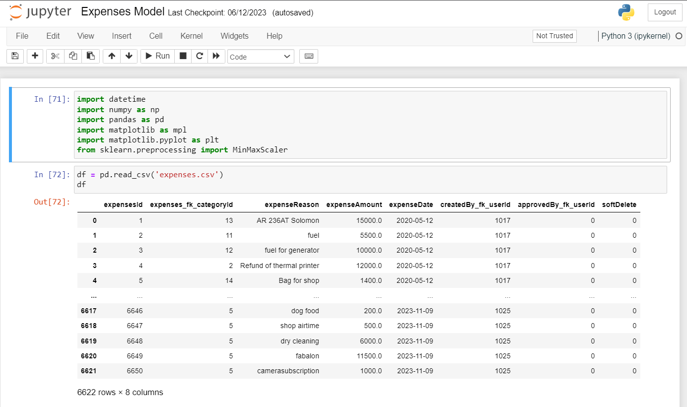

Here we see two cells, 71 and 72 performing two different tasks. Cell 71 importing dependencies for the data preprocessing, and cell 72 reading the CSV file containing the data used for training.

The Dependencies used in data preprocesing and training, i.e, the Libraries used in implementing the ML model. Pandas, Numpy, Matplotlib, Sklearn, and TensorFlow's Keras.
Numpy, Pandas, and Matpotlib are the primary libraries used in most model creation processes, they are involved in the preprocessing stage, for instance in this model, I had to;

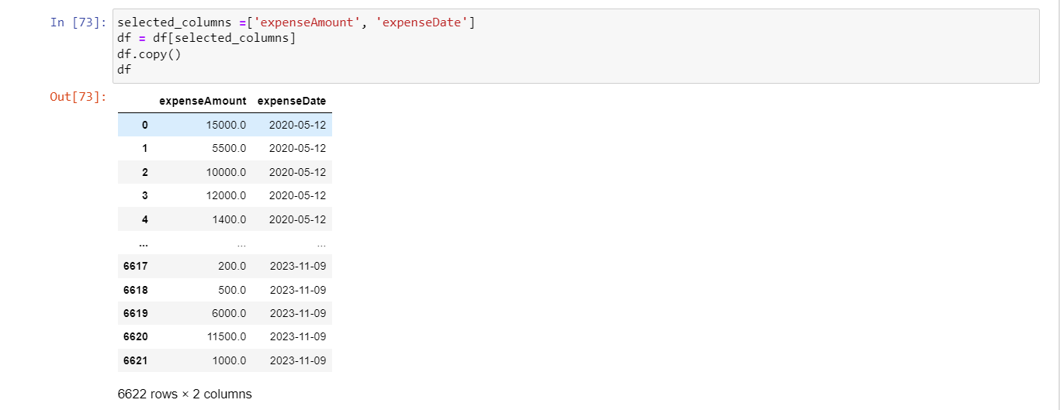
- Remove the unnecessary columns and create a copy of the new dataframe showing the important information.

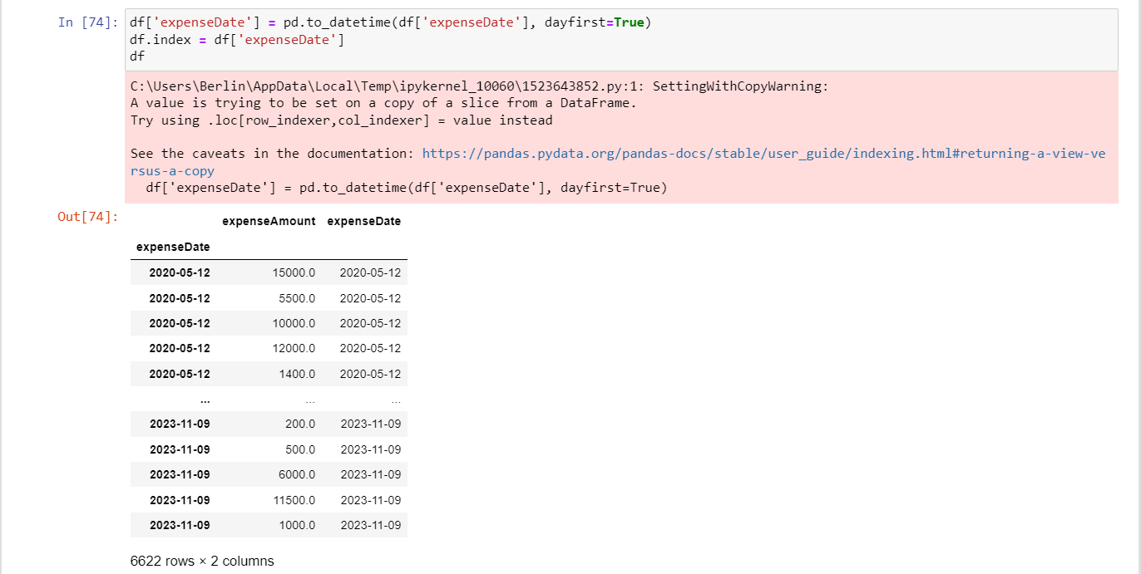
- Convert the date and time to the appropriate datetime format and push the date to the index column.
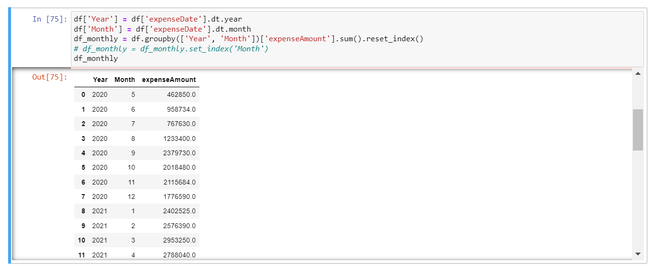
- Show more information on months of the year and associated sale/expense value

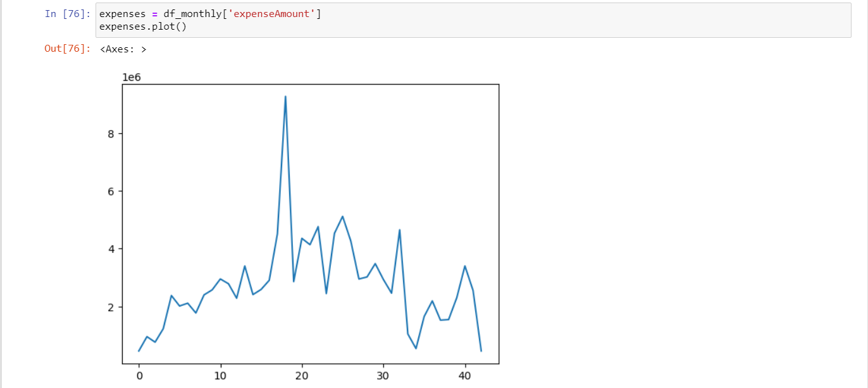
- Provide visualization of data

These are most of the tasks I was able to do to help preprocess the data, with the help of Numpy, Pandas, and Matplotlib (which I didn’t really use).
Then lastly I used Sklearn’s MinMaxScaler to scale the data, as so;

DATA PREPROCESSING

The data processing stage is most crucial stage in the building of a machine learning, here you have to get enough data to feed to the model, and ensure that the type of data you give the model is the accurate type. This process involves abstraction, removing null values, scaling if needed. I actually only performed organization of the data, visualization and scaling.
- I organized the data, as the raw form of the data couldn’t be used to train the model, it was a data-frame that had about 10 unnecessary columns, and I only needed 2, the date and the expense/sale amount for each corresponding date.
- Then there needed to be some sort of visualization of the data, so we observe the trends with the eye, and confirm the arrangement of the data.
- Then Scaling, generally it would be very hard to work with data that has very high values, in this case, combining the daily sales of each month into that month, the data will start to have values reaching 10’s and 100’s of thousands. This will most likely make the training of the model difficult, the model will be unstable, and the errors will be very high, also a chance of overfitting and underfitting will likely show up. So reducing the values so the model can easily train with them is what scaling does, recalling…, I used Sklearn’s MinMaxScaler to scale, this changes all the values in the data to a value between 0 and 1. So the model will train with values like 0.4, 0.543, 0.827, instead of the usual 200000.
- The window; The window here talks about how far back should the model fetch data to use to predict the next data. From here we start to discuss the implementation of the model itself.
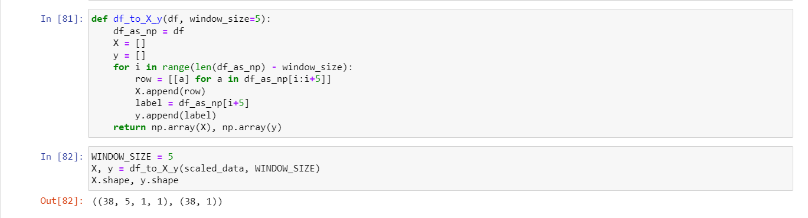
Here the function that creates the window. The model will take in an input X, and will have a target output Y, the architecture of the model is as simple as this. You want to give the model an amount of x months to predict how much will be in y month. For instance last 5 months worth of data(January, February, and March) to predict the next month(April). That’s exactly what the function does, I passed all the data into the function, with the amount of months I want to use to predict the new month ahead, and the function creates two arrays, the X array with 5 months of data, and the Y array with the next month’s data.
- The last step for the data processing is the test, train split. Here the data is split into train set, validation set, and test set. When building a model, there are steps, that us the training of the model as we know it (making the model know how to make predictions), and the test, used to generalize the data, meaning the model will also learn to make predictions based on other sources of data, and not only the training data, for the validation, overfitting and underfitting is tackled, as it’s used to test the hyper-parameters.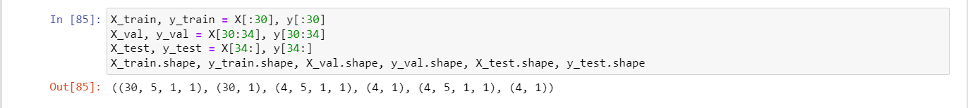
Here is the snapshot of the training and testing split…

…and the result of the scaled data
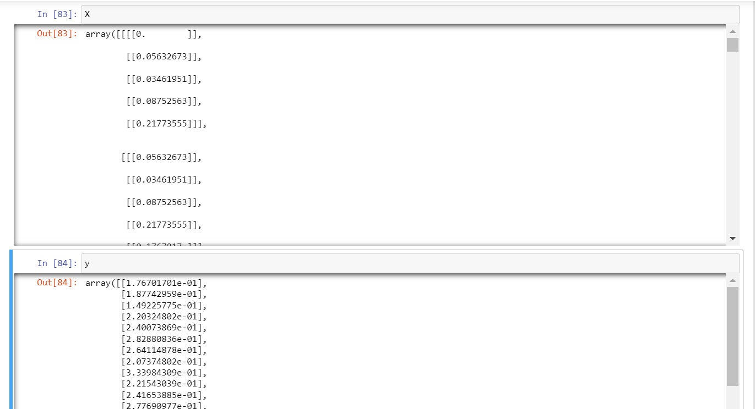

LSTM AND RECURRING NEURAL NETWORKS

The machine learning algorithm employed for the model is the neural network, actually a type of recurring neural network called the LSTM, for the sake of clearance and unnecessary information, the idea of the neural network, the recurring neural network and the LSTM will be explained briefly. The Neural Network assumes a structure of network with layers, the input layer, hidden layer, and the output layer, with nodes and biases in each layer. The nodes in the input layer collect data for processing, the nodes in the output give out the result, and the input nodes are used for computation, for the recurring neural networks, the difference is the way the network collects data and computes them, the normal neural network collects data, computes it, and just gives an output, but the recurrent actually collects data, computes, collects data, compute again, it follows this cycle of collecting and computing to give the desired result, as the subsequent data collected will play a role in the output, then the LSTM.
The LSTM is a type of recurring neural network that focuses more on the short term information and keeps important information about the long term information, as the name implies, LSTM meaning Long-Short Term Memory.

LSTM NETWORK MODEL IMPLEMENTATION
The LSTM model was implemented using a framework TensorFlow. TensorFlow is a python oriented framework that is used to create neural networks of different kinds. Here is the implementation of the LSTM model using TensorFlow.
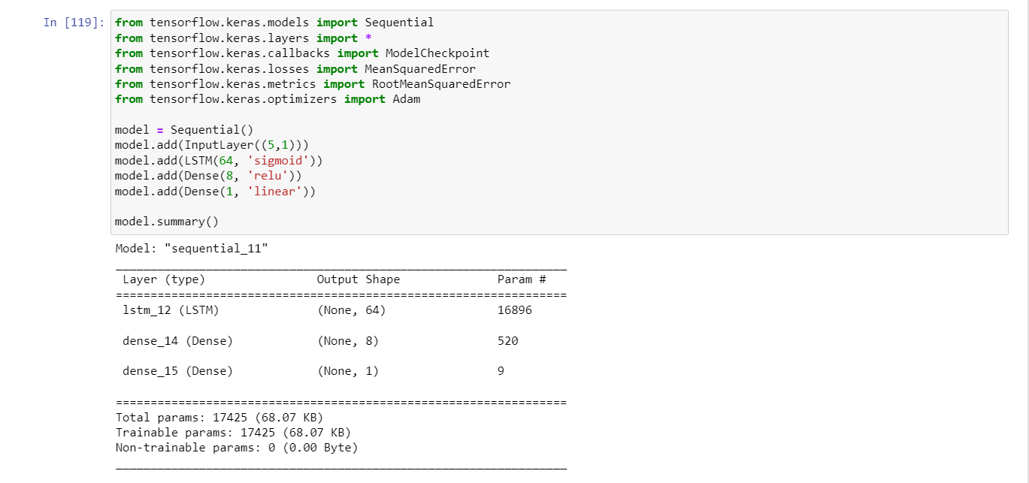
The first 5 lines are the imports for the TensorFlow dependencies, that is the sequential model, all the types of layers in TensorFlow, the Model Checkpoint tool, the loss function for the training, the metrics for the training, and the type of training algorithm, respectively.

Next is the training process itself
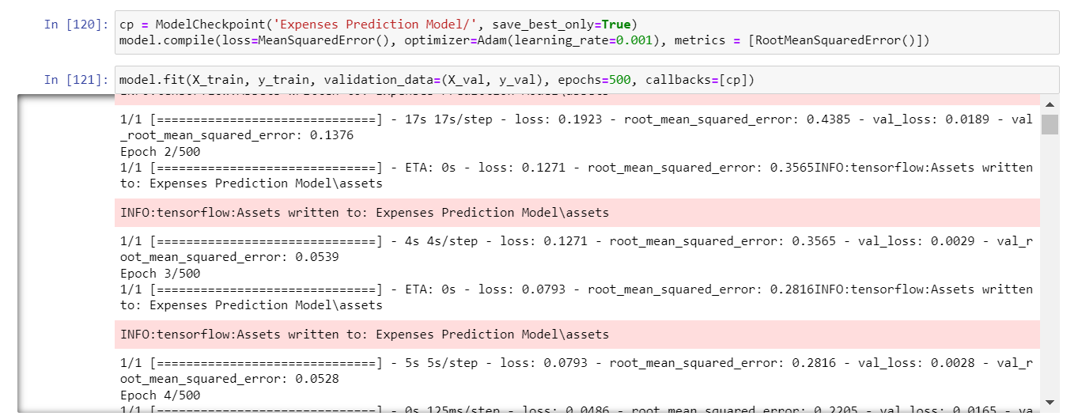
Here the hyper-parameters are defined, the epochs, the learning rate, the loss function and the training metrics. They all affect the outcome of the training process.
The checkpoint function is also called to saved the model at a particular point, and I chose to create a checkpoint at the lowest validation error, so as it’s training whenever the model achieves a lower error than the last, the model is saved.
Cell 121 (model.fit) contains the code that runs the training of the model.
Supplementary Information about the training process:
- Epochs means the number of times the training will occur, best practice is to keep an epoch number that captures the lowest training value, as a lower training value might be missed with a low epoch.

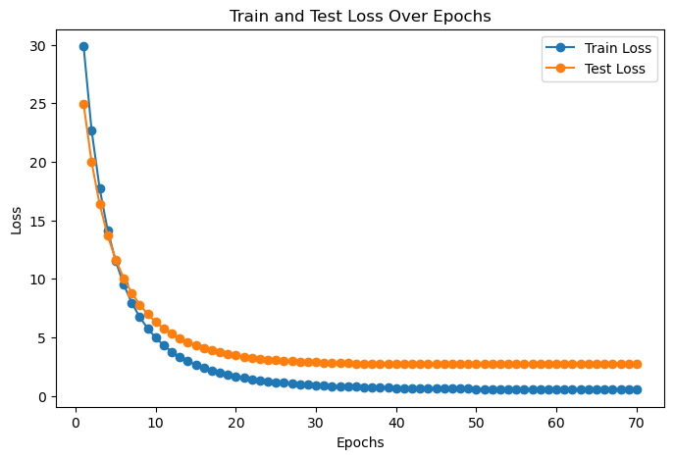
This graph explains how epochs work, as we train over a certain number of epochs, the error starts to reduce, and about epoch 30, the error can no longer go any lower, so we’ve been able to capture the lowest error we can with our hyper-parameters, but if maybe we had set our epochs to 20, our model will assume a loss that is not the best it could have gotten.

- Optimizers are what does the training, the training works like this:
First, there is a target value (y), the model uses the input values (x) and makes it’s own prediction, then it compares it’s result with the target value, and produces an error.
It keeps making predictions on it’s own until it starts to get a value close to the target value (y), this is where we start to see the error getting close to zero. That is basically how training works, and there are different functions that perform this training, like SGD (Stochastic Gradient Decent), Adam (Adaptive Momentum), Batch Gradient Descent , etc. In this process Adam was used because of my familiarity with Adam.

TESTING, VALIDATION AND PREDICTION GENERATION
This is the final step where we use the trained model to make predictions on seen and unseen data, generally to check the quality of the model.
First, I have to upscale the model back to it’s original scale of 10000’s and 100000’s, so it doesn’t give decimal results from our initial scale.

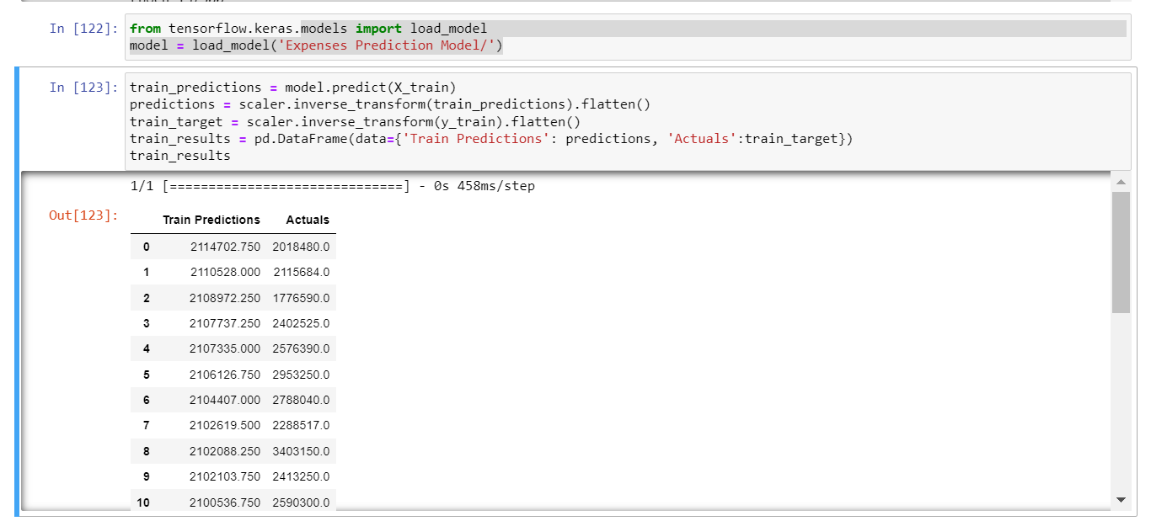
The model (with the lowest error from the checkpoint) is loaded from memory and is used to make predictions using the built-in predict function, then I do an inverse scalar transformation on the values, then compile them into a data-frame comparing the results of the actual target values (y) and the models prediction.
This is repeated for the test and the validation sets.

Below lies a snapshot of the code from beginning to the end.
THE PROGRAM TAKE THE SAME FORMAT AND PROCEEDINGS FOR THE SALES PREDICTION MODEL.
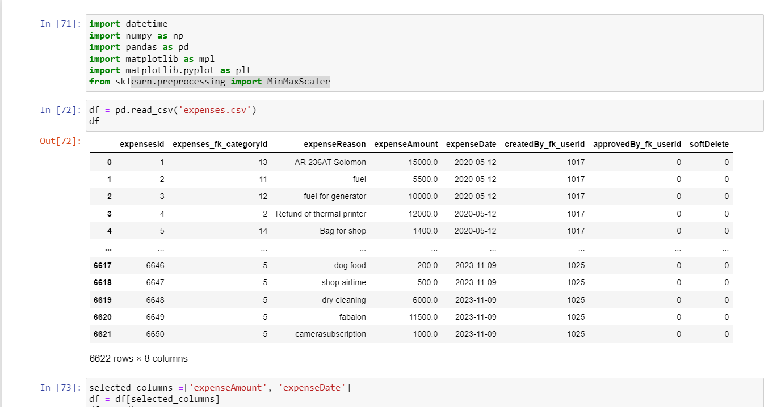
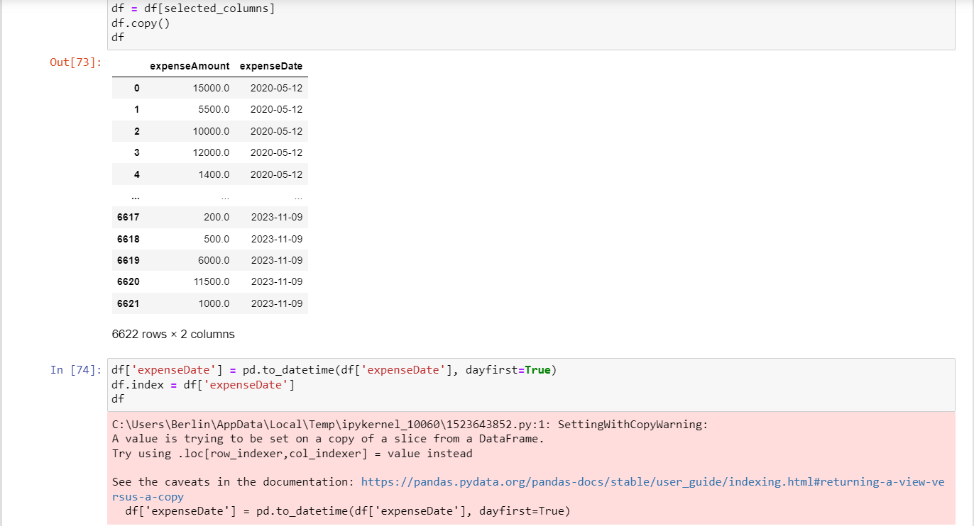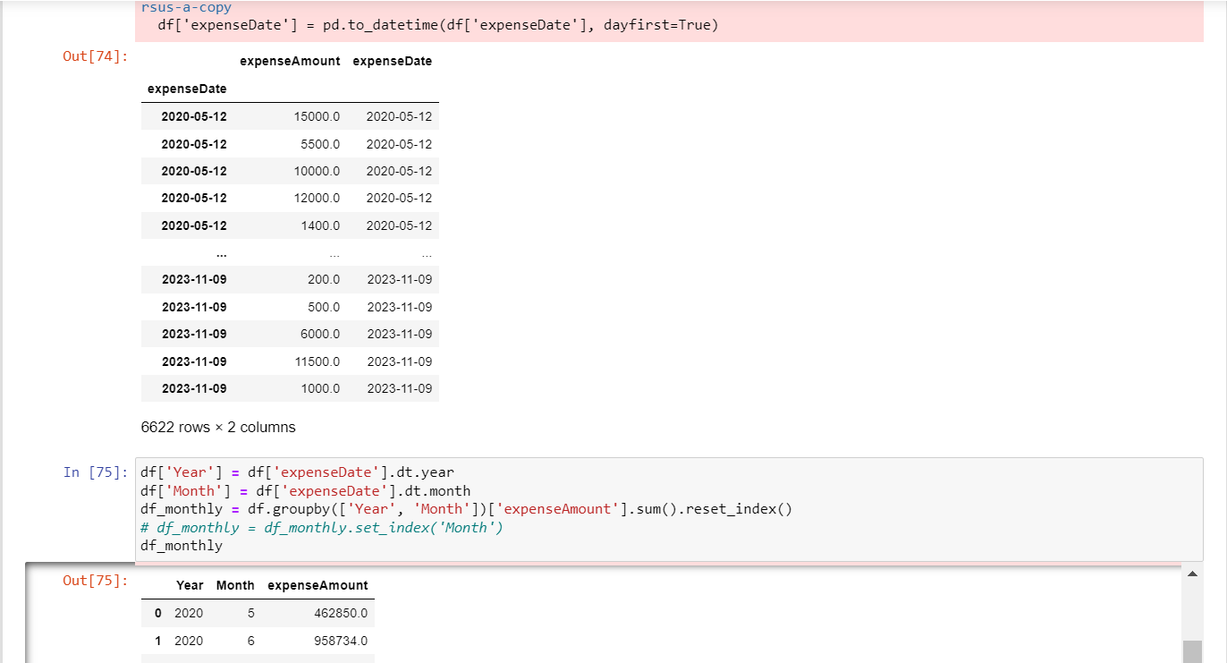
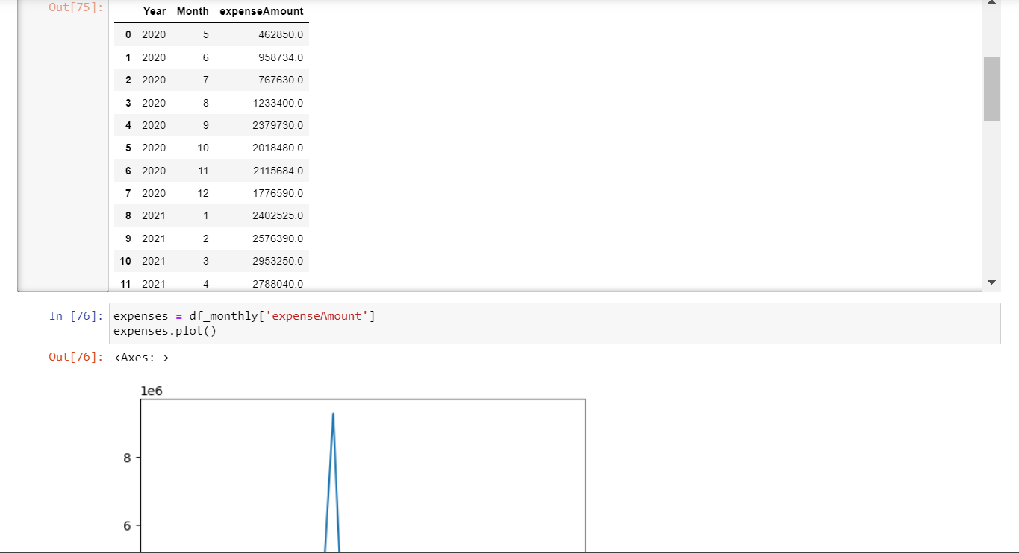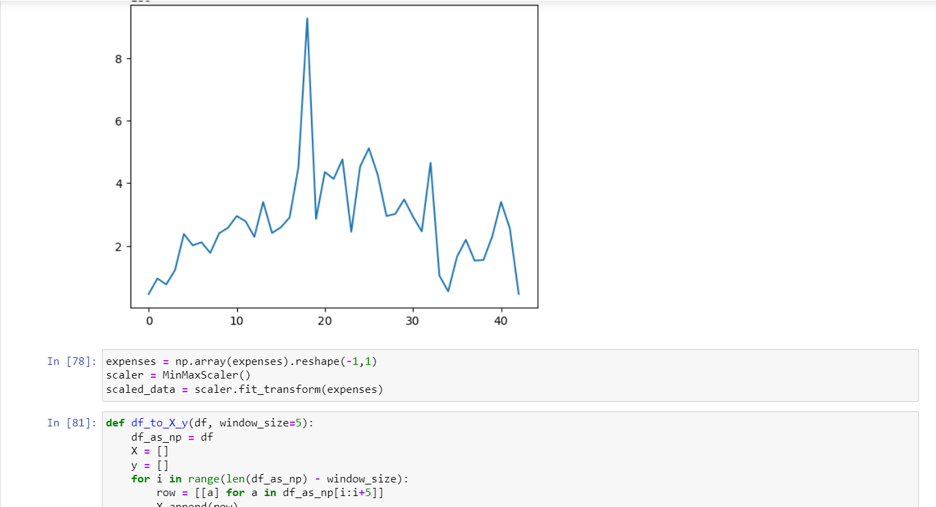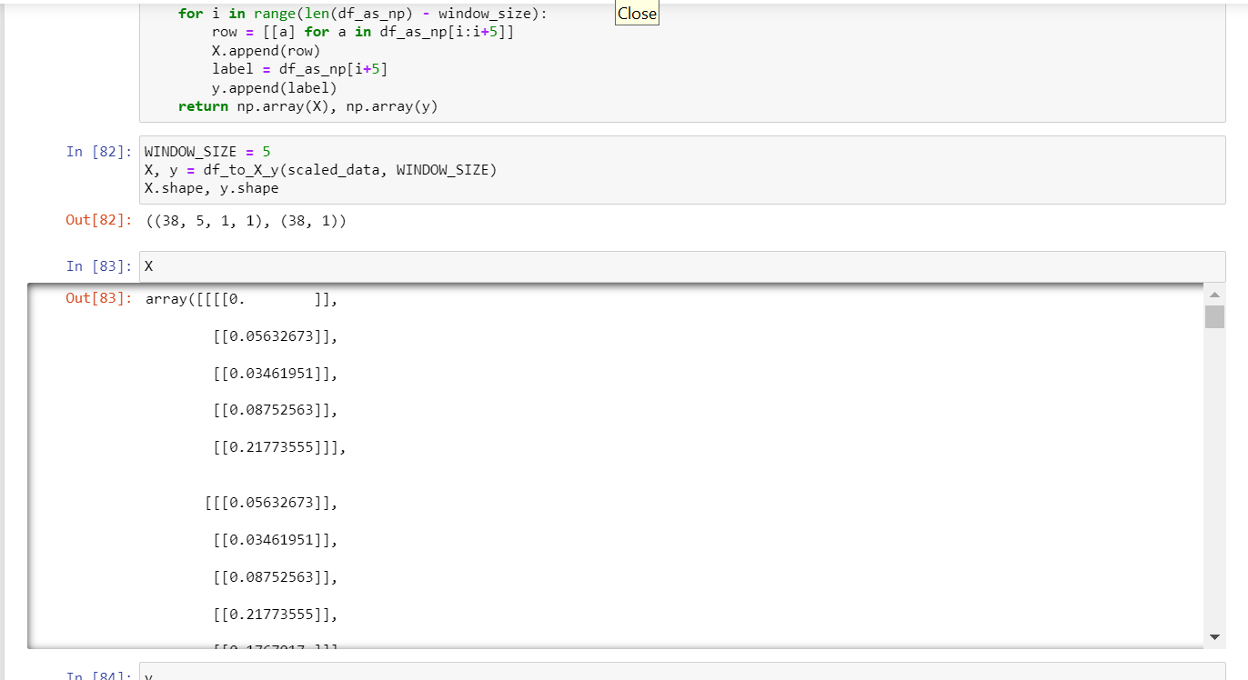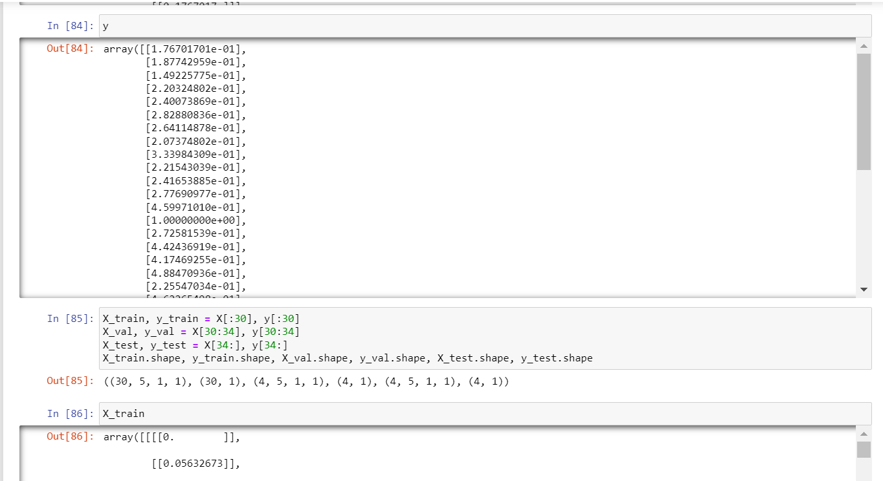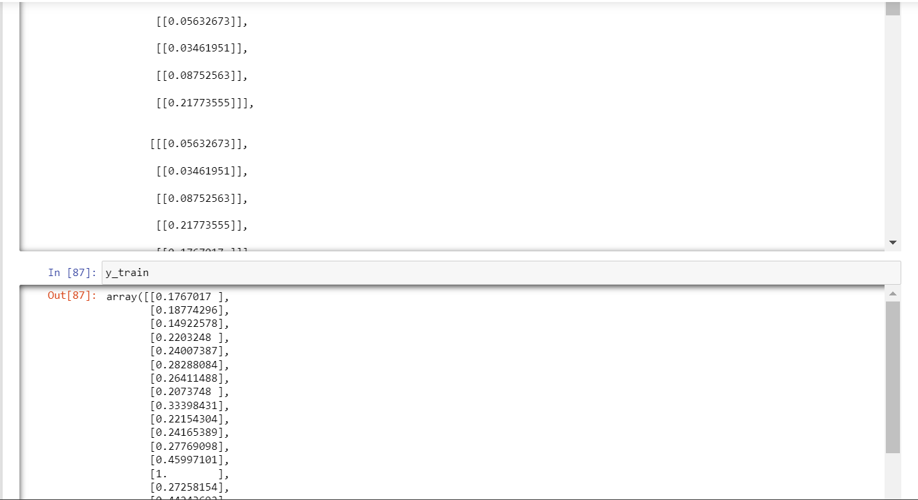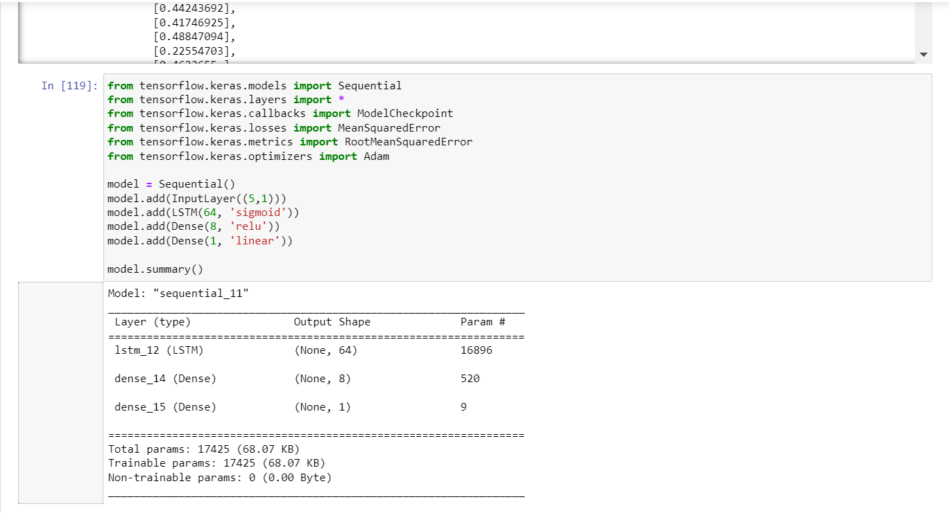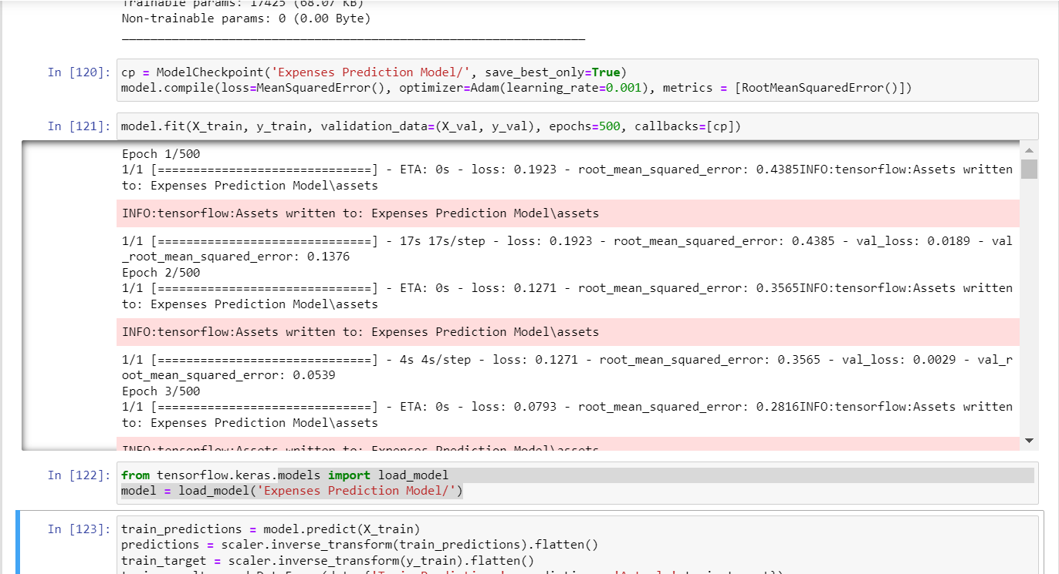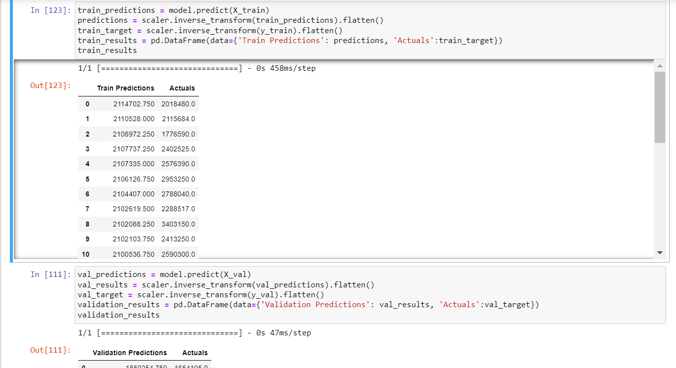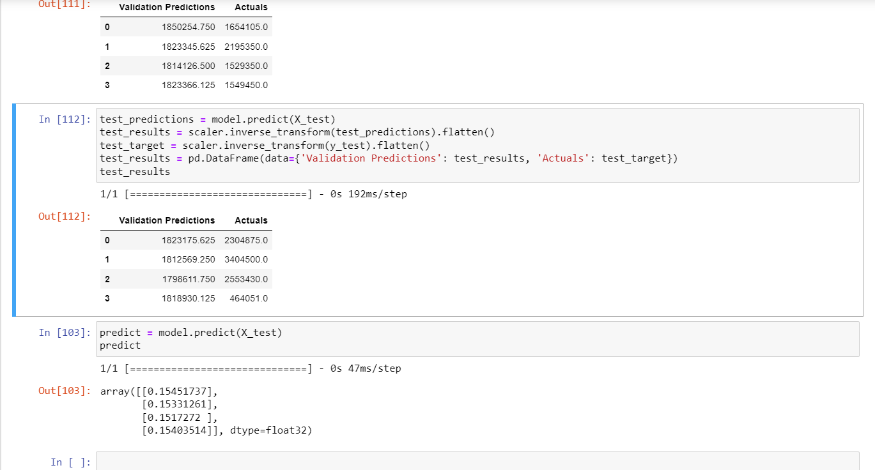

CONCLUSION
The Models for the Areeta Sales and Expense Prediction are developed using the LSTM Network, and Tensor-flow Framework, the prediction accuracy is good, and can definitely get better overtime.

